NX4 Cam Express using SE V19 and NX4.0.2.2
From Glynne Daniels UGS UK
glynne.daniels@ugs.com
Monday, January 15, 2007
Version 1.1

Requirement 1

System Patch:-

**** NOTE if you are using SE v17 or V18 patch is not required ****
**** This patch is NOT required if using a 64-bit system ****

PROBLEM:
Opening Solid Edge V19 files will now require that a Microsoft
redistributable for VC++8.0 runtime libraries be installed on 32-bit
systems. Without these files, if NX4.0.2 users are supplied files from
Solid Edge V19, there will be no available geometry when opened.
If NX4.0.2 is being run on a 64-bit system, or if Solid Edge V19 is
installed on the same system as NX4.0.2, this will not be necessary. In
both of these cases, the Redistributable patch is a requirement.

REMEDY:
These libraries install runtime components of Visual C++ Libraries required
to run applications developed with Visual C++ on a computer that does not
have Visual C++ 2005 installed. The Microsoft Visual C++ 2005
Redistributable Package (x86) executable file name is'vcredist_x86.exe' and
can be downloaded from:

http://www.microsoft.com/downloads/details.aspx?familyid=32BC1BEE-A3F9-4C13-9C99-220B62A191EE&displaylang=en

Requirement 2

Once installed, set the following environment variable:

UGII_USE_SEV19=1

Edit the text file nx4\ugii\ugii_env.dat file and add the above variable name.

This will load the Solid Edge V19 adapter when Solid Edge parts are opened
in NX4.0.2.2

Requirement 3

Installing Post processors from a folder (not via the Post Processor download route, see below as this is a reminder on where the “Off-the-Shelf” post processors resides)

http://ftp.ugs.com/unigraphics/pb_posts/post_index.htm

The post processor installation.

Make a folder called customer_posts and copy all the data from the media to this folder.

NX4 Configuration Files

The NX4\MACH\resource\ directory will be used to contain your postprocessors.
The environment variable is UGII_CAM_RESOURCE_DIR.
(usually nx4\mach\resource\postprocessor)
This indicates this directory, which defaults to $(UGII_BASE_DIR}\mach\resource variable.

- In the customer_folder:- edit the file template_post.dat file and copy the 1 line and past it into the template_post.dat file that resides in the nx4\mach\resource\postprocessor folder.
- Copy the 3 files called :-
haas_vf2_ss_5axis.tcl
haas_vf2_ss_5axis.def
haas_vf2_ss_5axis.pui
to the nx4\mach\resource\postprocessor folder.

****** NOTE******
Use the interface in TOOL >Install Post processors>….. add new description
Into this page showing the interface…..
January 15, 2007

Requirement 4

Updating the UDE ( User Defined Event )

In the folder nx4\mach\resource\user_def_event copy the file ude.cdl to ude.cdl_original

Now, from the customer folder copy the file ude.cdl to :-

nx4\mach\resource\user_def_event
This UDE contains a unique inferface for the haas 5-axis post processor and haas 4-axis post processors. Interface is reflected in the haas template part file
Example of configurable dialogue for this post processor is shown below:-

VERSION 0.1 10 OCT 06
# PROG IDENTIFIER
#

MACHINE FANUC

#---------------------------------------------------------------------------
# Start support (Haas )

EVENT prog_identifier
{
UI_LABEL "Programme Identifier"

PARAM prog_name
{
TYPE s
DEFVAL "1999"
UI_LABEL "Programme Identifier"
}

PARAM mam_part_text
{
TYPE s
UI_LABEL "Part Description"
DEFVAL "None Specified"
}

PARAM mam_prog_text
{
TYPE s
UI_LABEL "Drawing Issue"
DEFVAL "0"
}

}

EVENT superstop
{
UI_LABEL "Super Operation Stop"

PARAM command_status
{
TYPE o
DEFVAL "Active"
OPTIONS "Active","Inactive","User Defined"
UI_LABEL "Status"
}

PARAM superstop_type
{
TYPE o
DEFVAL "Stop"
OPTIONS "Stop","OptionalStop"
UI_LABEL "Type"
}

PARAM superstop_text
{
TYPE s
TOGGLE Off
UI_LABEL "Operator Message"
}

}

# end of support -

Creating a Template (NX4)

A template is a predefined operation or group within a CAM part file. An experienced NX CAM user or System Administrator should manage the Template Part Files for the rest of the user group.

Template Part Files may be created new or by copying, customizing, and renaming existing NX supplied templates. Template Part Files may contain many operations and many groups. You can specify which operations and groups are to be used as templates by choosing the Template Setting option in the Operation Navigator. With the template part file displayed, highlight the desired operations or groups in the Operation Navigator and use the third mouse button (MB3) to choose Object—>Template Setting.

This displays the Template Setting dialog box containing two toggles: Template and Load with Parent. If the Template option is toggled ON, the highlighted operations or group will be available as a ICON whenever this part is used as a template part file. In other words, all operations and groups for which the Template option is toggled ON will appear as subtype icons in the appropriate Create Operation, Program, Tool, Geometry, and Method dialog boxes.

In the following figure, al the operations need to be highlighted, and then using 3rd mouse button, select :- Object->Template Setting.

In the Template Setting dialog box, Template is toggled ON (it is a good idea to be sure that Template is toggled OFF for those operations you do not wish to be added as templates). Then Select OK.

Once all the groups and operations to be used as templates have been specified in this way, the part file is then saved in the appropriate directory (preferably in some organized manner with your other templates). In this example, the part file was saved as "tool_template".

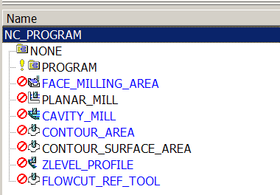
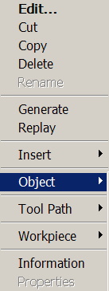
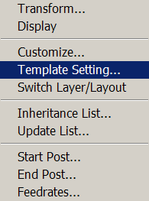

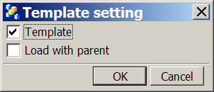
Now set the check box as indicated

The “tool_template” may now be used as a Template Part File for creating new operations. Retrieve the part for which you wish to create a new operation.

In the Create Operation dialog, specify “tool_template” as the Type. Depending on the directory in which you saved the “tool_template”, you might need to Browse or use the Pallet option as described earlier.

Once “tool_template” has been specified as the Type, all the operations you specified as templates, Cavity_Mill, face_milling_area etc, appear in the subtype section of the dialog box as icons as illustrated below.

Operations may use the default icons as illustrated below or custom icons. Customized icons must be saved as .bmp files in the ugbitmap directory.
Refer to the discussion of User Tools in the Gateway Online Help documentation.

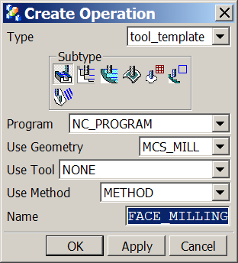
Template Part file

Icon names from template settings

Setup Assemblies; Using an Assembly Part as the Setup Template

This functionality allows the system to automatically replace a component to be manufactured, in a manufacturing assembly, eliminating the need to manually replace the component.
You can also create several CAM assemblies for a single work part. This allows you to divide the CAM data in several files, or allow several programmers to be working on the same part.
Mating conditions can be used in the setup template to locate the target component relative to clamps, fixtures, or other resources. If your work part has the same face attributes, the mating conditions allow the work part to be positioned correctly when replacing the target component.
In short, to create a CAM setup that uses assemblies, you will add a simple component to an assembly to represent a typical work part, then assign the attribute CAM_COMPONENT_TYPE=Target. When this setup is used, the target component is replaced with your work part.
The advantage is that the new component to be machined is automatically substituted in a MFG Assembly and correctly mated to a fixture, then once the setup is initialized you simply reselect the geometry and generate the operations.
The following example describes how this is accomplished.
- Set the environment variable “UGII_CAM_CONFIG” to “cam_library.dat” to ensure library setups will be used. This file will define “LIBRARY_SETUP_TEMPLATE” which will specify setup assemblies may be used.
- Create a new part file in Unigraphics NX CAM and add the component to be machined along with any fixture components and apply mating conditions.
- Highlight in the Assembly Navigator the component that will be the “target” to be replaced in the assembly and select ‘MB3→Properties→Attributes’ and specify the “Title” as “CAM_COMPONENT_TYPE”, and the “Value” as “Target”.
- Add face attributes to the component in the assembly and define alternate mating conditions to permit replacement of the component in the Mfg. Assembly with another and have it mated correctly. To accomplish this, highlight a mated face on the component then select ‘MB3→Properties→General(tab)’ and specify a name for the face. Do this on each face that has a mating condition. To associate the face attribute to it’s mating condition select ‘Assemblies→Components→Define Mating Alternatives’.
- Open the Mfg. Application and select any Configuration and Setup that will provide you with the necessary setup components to machine your part.
- Save the part once the manufacturing processes are complete and all Template Operations have the appropriate Template Settings specified.
- Select ‘File→Export→Setup Template’ which will bring up a series of dialogs which will permit you to select the appropriate “Library Class” you wish the assembly to be identified with, the Template Part Description which you will see when you retrieve the template in future use, and the list of Template Types that will be used when the template is retrieved. This data will be written out to the file “template.dat”.
The following example describes how the new assembly will be used.
- Open a component that will replace the one you specified in your new Assembly Template and from the Manufacturing Application select “cam_library” from the CAM Session Configuration list.
- Selecting cam_library brings up the Library Class Selection dialog containing the Setup Tree. From this tree select the Library Class you defined for your Template Assembly.
- From the list that appears select your assembly.
- When you select your assembly the “Save Part File As” dialog appears, ready for you to save your new assembly part file. The new part file you are creating by entering a name in this dialog is the part file in which your NC Program will be created. Save the part as “mfg_assembly_1.prt”. This will take your new component and replace it in your assembly and save it as “mfg_assembly_1.prt”.
- With “mfg_assembly_1.prt you can begin selecting geometry and generating the operations that were created when you initialized the setup with your Assembly Template, while referencing your component in your Unigraphics NX window.
After you have created a setup assembly, if you delete the setup, the assembly is not deleted. If you create another assembly setup, a new assembly will not be created -- the setup is created in your work part.

Setup Templates ONLY
Now this is how be accomplish template usage in a NX Cam express environment that use the SETUP configuration only.
(IE : loading the part to the setup)

In the folder nx4\mach\resource\template_part\metric

For example there are 3 files called
- Machinery_exp.prt (template file containing icons for operations tooling etc)
- Machinery_express.prt ( contains program ID, Tool Carrier, MCS and workpiece and method groups, (this is by definition Load with Parent)
- Machinery_express_target.prt (In short, to create a CAM setup that uses assemblies, you will add a simple component to an assembly to represent a typical work part, then assign the attribute CAM_COMPONENT_TYPE=Target. When this setup is used, the target component is replaced with your work part.
To adapt a configuarable solution for customers that has specific manufacturing and post porcesor interface requirements, this us how you accomplish this feat????

Item1) Copy the file Machinery_exp.prt to for example :-
haas_template_express.prt
Item2) Copy the file Machinery_express.prt to for example :-
haas_express_ link.prt
Item3) Copy the file Machinery_exp.prt to for example:-
haas_express_target.prt

Item1
Customize this file with appropriate temple setting for each object:-

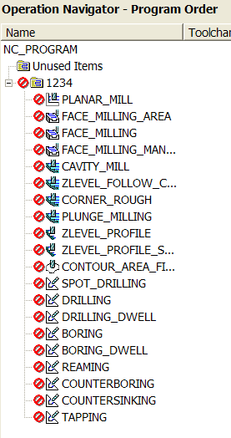
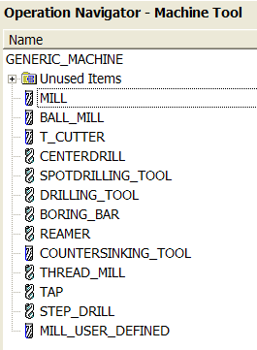

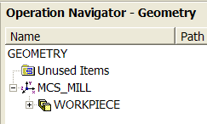
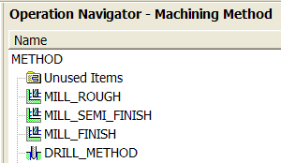

NOTE

All the object need to be set to :- ( Highlight object in the ONT, (Operational Navigation Tool) then using 3rd mouse button, drop down to OBJECT and select Template Settting and set the following:-

Item2

haas_express_ link.prt is used as a master assembly that allows the component part to be brought into the setup and positioned at absolute zero

A must setting in the link file :-

- Highlight in the Assembly Navigator the component that will be the “target” to be replaced in the assembly and select ‘MB3→Properties→Attributes’ and specify the “Title” as “CAM_COMPONENT_TYPE”, and the “Value” as “Target”.

This will be automatically set up because we initially copied the machinery_express.prt file and the attribute name will change automatically when the target file is loaded. In our case the attribute name is :- CAM_COMPONENT_TYPE=Target
And this part file haas_express_ link.prt contains an assembly to include the haas_express_target.prt

NOTE
This is a PLACE HOLDER part file as used by Solid Edge
( i.e. dummy)
Now for the TRICK

In the file haas_express_ link.prt

In this part file you have the capability to add objects such as pre-defined cutting tools and method groups etc and if you require these to be automatically loaded into the Operational Navigation tree

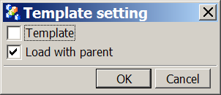

Now to complete the exercise, we need to edit the template.dat file that resides in

\nx4\MACH\resource\template_dir
And add the following line :-

# Setup templates added by users should only use librefs greater than 200
#
DATA | 201| express.| ${UGII_CAM_TEMPLATE_PART_METRIC_DIR}haas_express_link.prt | ${UGII_CAM_TEMPLATE_PART_METRIC_DIR}haas_template_express.prt | Express Machinery Assembly | Metric

Ensure that the Roles have been setup for NX4 Cam Express prior to running NX.

Part Templates ONLY
Now this is how be accomplish template usage in a NX Cam express environment that use a unique part file configuration only.

This practice is used when a manufacturing template is loaded to the component part file.

Example:-
load the haas_template.prt and set up the requirements.

Now add the following line into the template.dat file that resides in the mach\resource\template_dir folder

# The following line will provide a direct link to the Haas customised template part and does not use a SETUP as specified in the previous example.

DATA | 202| express.| ${UGII_CAM_TEMPLATE_PART_METRIC_DIR}haas_template.prt | ${UGII_CAM_TEMPLATE_PART_METRIC_DIR}haas_template.prt | Express Machinery Assembly | Metric

In the Machinery Express Pallet tool bar you should now see the 2 configurable items here.

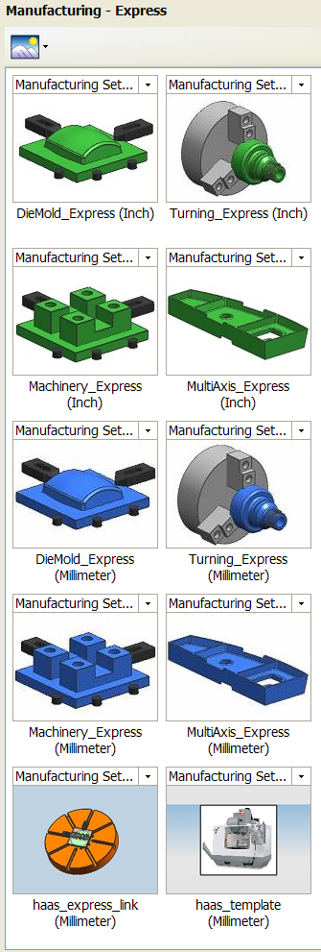

Part Template Icon

Setup Template Icon

Technical Note.

How do you get a jpg image to import into NX4 part file :-

Edit the jpg file with PAINT software and then File SAVE AS with a .tiff extension.

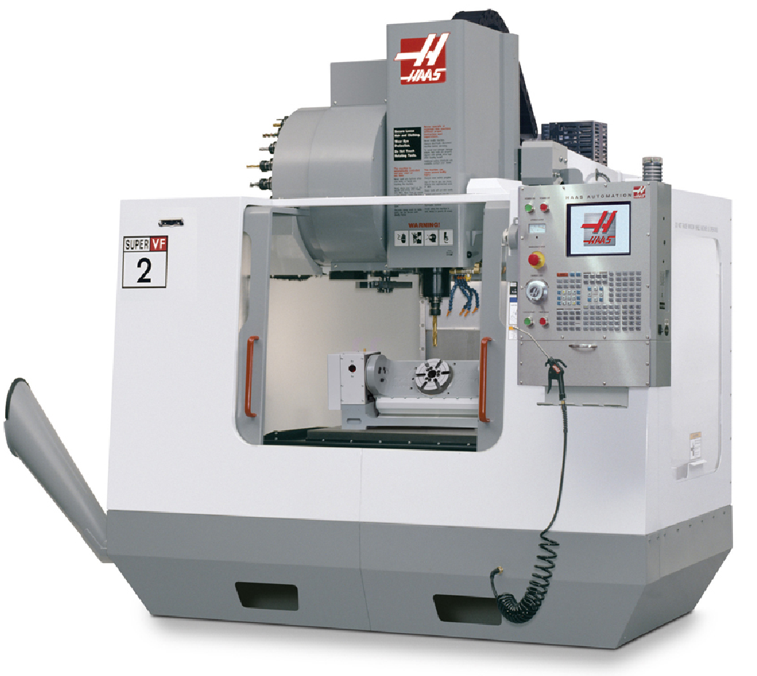

Now open up the haas_template.prt file
Go to Gateway choose View, Visualization, Raster Image, Specify TIFF image,
Then select Create Raster Image.
Rotate graphics and obtain the best view, (Top is preferred) blank the solid model from the screen and file the part.

Note on Post processor

The Haas 5 axis post processor has been optimized and the A-axis trunnion will never move back into the machine. Movement is restricted from 0 degree (vertical face will in front of the operator and then to a horizontal position of 90 degrees This is because the m,achine tool operator cannot see the part being cut on the back side
Therefore, the post has been optimised and the c-axis will be compensated automatically.

